Chapter 4 File Systems and Internet
Session Objectives

At the end of this session, the student will be able to -
- Explain the concept of Partitions and Volumes
- List the File Systems supported by Windows NT 4.0
- Explain the Features of File Systems supported by Windows NT 4.0
- Differentiate between FAT and NTFS file systems
- Explain User accounts
- Define User Profiles

- Discuss what is the Internet
- Explain the Origin of the Internet
- Explain Client Server Basics
- Describe electronic mail
- Explain Telnet
- Discuss FTP
- Discuss the World Wide Web
- Explain Search Engines
- Discuss HTML
- Explain TCP/IP fundamentals
- Discuss applets and their usage in html documents
- Discuss the uses of the internet with special focus on e-commerce, on-line supermarkets, universities and on-line courses.

I. File Systems

You now have a fair idea of the Windows 2000 Workstation interface. You also learnt about advantages of living in the network neighbourhood. In this chapter we will take a look at the concept of partitions, volumes and File Systems supported by Windows 2000.

- Concept of Partitions

Disk partitioning is one of the disk management techniques. It refers to the logical division of the hard disk. It divides the memory unit into isolated sections. Before a hard disk is formatted with FAT or NTFS file system(s), a partition should be marked on it to contain the file system. This also happens during partitioning. A hard disk can contain one or more partitions. Partitioning is particularly useful if you run more than one operating system.

Windows 2000 supports three types of partitions:
- Primary partition
- Extended partition
- System partition

Primary Partition

The first level partitioning of the disk is known as the primary partition. A primary partition can be created to occupy the entire hard disk or one portion of it. any hard disk can have a maximum of the four partitions and all four can be primary partitions. After partitioning, each primary partition should be formatted with the limitation that a primary partition should be formatted as a single logical drive only. It cannot be subdivided into more than one logical drive.
Any primary partition on a hard disk can be designated as the active partition. Let us consider a system with two hard disks. Out of these, one of the primary partitions on the first hard disk is designated as the active partition. After partitioning, each partition is made to hold an OS. When the computer boots the operating system present in the active partition gets loaded. Therefore, it is also known as the boot partition.

Extended Partition

This is a scheme, where primary partition are further divided into sub partitions. Thus, the primary partition subdivided is known as the extended partition. The sub partitions are the logical partitions. This is done to again facilitate storage of more operating systems. A hard disk can have any number of primary partitions but only one extended partition. Normally, the system partition cannot be located on an extended partition. the boot partition however can be located on an extended partition. An extended partition cannot be made active. Hence, it cannot contain the OS, which you want by default to get loaded on starting your machine.
Similar to the primary partition, extended partitions also can be formatted to create drives. Any number of drives can be created on an extended partition, unlike in primary partitions. You can designate each drive by an alphabet. You can format one logical drive with FAT, another with NTFS from the same extended partition.

Figure 0a is an illustration of a hard disk with one primary partition and one extended partition. The extended partition is divided into logical drives.

Primary partition
Extended partition
Logical drive E:
Logical drive F:
Logical drive G:

Figure 0a: A hard disk with a Primary partition and Extended partition

System partition
The system partition contain the hardware-specific files required to load Windows 2000 (for example, Ntldr, Osloader, Boot.ini). It is possible that the system partition and the boot partition are the same.
In Windows 2000, the system partition must be located in the active primary partition of the first hard disk.

- Concept of Volumes

A fixed amount of the storage space on a medium such as hard disk is known as a volume. Each volume has a label. A volume may span over more than one disk also. It encompasses the partitions. This structure is imposed generally to allow indexing of the files. A volume contains root directory, which has table of disk contents. It also has the allocation table, which contain entire about the occupied spaces. File system operates with volume information to determine the file addresses on the disk. In Windows 2000, we get some additional information like the disk space available per user and adding space to an existing volume without resetting the computer.

- File Systems

Just like you have cabinets and filing systems to store all your files, so also a computer system needs a filing system to store data and applications. In a computer system, everything is stored in a file. These may be data files or application files. Each operating system has its own way of organising data internally. The type of file system that is used determines how data and programs will be accessed. It also determines the level of access available to users of the system. Table 1 describes some operating systems and the File Systems they support.

Operating system | File systems supported
Windows NT 4.0 | FAT, NTFS, CDFS
Windows 95 | FAT, CDFS
Windows 3.x and 3.1x | FAT, CDFS
MS-DOS | FAT, CDFS

Table 1: Operating systems and file systems they support

As is seen in Table 1, Windows NT supports three file systems:

- The File Allocation Table (FAT) file system

- The Windows NT File system (NTFS)

- The Compact Disk Filing System (CDFS)

3.1 FAT

The file allocation table (FAT) file system has been around since the advent of the PC. The FAT file system used by Windows 2000 is a modified version of the FAT file system used by MS-DOS.

 Windows 3.x, Windows 3.1x, Windows 95 and MS-DOS support the FAT file system. So if the system is to be configured to dual boot between Windows NT and Windows 3.x, Windows 3.1x, Windows 95 the first partition must use the FAT file system.

The Windows NT FAT file system is different from the FAT32 file system supported by Windows 95. Windows NT does not support the FAT32 file system.

Features of the FAT file system

Naming Conventions – In the FAT file system used by MS-DOS the file name could be only 8 characters long. FAT is also case sensitive. That is, a file saved as MINE.DOC would have to be retrieved in the same manner. Mine.doc will not do.

In Windows NT, the FAT file system is a little more accommodating:

- It supports long file names

- The full path of a file (including filename) can be up to 255 characters long

- File names can contain any character except “ / \ [ ] : ; | = , ^ ? a "

- File names should begin with an alphanumeric character

- File names can have spaces and multiple periods. The characters after the last period are treated as the filename extension.

- FAT still supports uppercase and lowercase in file names

- File names are not case sensitive. That is, MINE.DOC could be retrieved as Mine.doc, MINE.DOC, or mine.doc

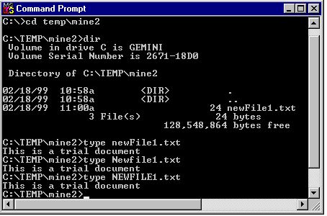
Figure 0b

- Security – Security is an important feature supported by Windows NT. FAT however, does not support local file and folder security in Windows NT. That is, any user logged on locally to a computer has full access to the files and folders in the FAT partition (s) of that machine.

The good part is that access can be controlled when on the network. Shared permissions are used to control users access to shared files and folders on the network. So if security is to be implemented even for local access then NTFS is more suitable.

Advantages | Disadvantages
Shared permissions can be used to restrict access to shared files / folders over the network. | Assigning shared permission is ineffective if the user logs in locally to the computer.
 | Shared permissions cannot be assigned to individual files in a folder.

- Quick access to files - The speed of file access depends on many factors:

- file type
- file size
- partition size
- fragmentation
- number of files in a folder.

If the partition size is smaller than 500MB, file access is much faster than on other similar- sized file system partitions. On the other hand, if the partition is very large, or contains a large number of files and folders, then file access on an NTFS partition is much faster.

 A hard disk can be divided logically into a number of parts. This process is called partitioning of the disk.

The other concern is that of fragmentation. In a FAT partition, that is highly fragmented, access is slower than it would be on a similar sized NTFS partition.

 Data may not be stored in sequence in memory or on the disk. The data is stored in fragments wherever the operating system is able to identify free space.

- Partition size – The maximum size of a FAT partition and the maximum size of a file in a FAT partition is 4 GB. Moreover, files cannot be compressed in a FAT file system.

3.2 NTFS

Windows NT (both workstation and Server) is the only system that supports NT File System (NTFS).

Features of NTFS

- Naming conventions

The naming conventions followed by NTFS are:

- File names (including extensions) can be up to 255 characters.

- File names can contain most characters except ? “ / \ < > * | :

- Uppercase and lowercase file names are preserved.

- File names are not case sensitive (the exception is when used by a POSIX application).

 POSIX - Portable Operating System Interface for UNIX is set if standards. The objective is to define common interface standards for the UNIX environment

- Security

NTFS provides file and folder security. Thank God for that!! What it means is that when Windows NT is installed using NTFS, files and folders are safer than they are in the hands of FAT. Security is maintained by assigning NTFS permissions to files and folders. Security is maintained at the local level and the network level. Moreover, permissions can be assigned to individual files and folders. So how does it all work?

Each file or folder in an NTFS partition has an Access Control List (ACL). The ACL contains users and group security identifier (SID) and the privileges granted to users and groups.

- Access speed

If you want to install Windows NT on a partition size greater than 500 MB, formatting the partition with NTFS is more suitable.

- Partitions

NTFS partition and file sizes are much bigger than FAT partitions and files. The maximum size of an NTFS partition and files can be 16 exabytes (1 exabyte = giga-gigabyte). However, the practical limitation is two terabytes. The maximum file size can be 4 GB to 64 GB.


8 bits = 1 byte
1,024 bytes = 1 kilobyte
1,024 kilobytes = 1 megabyte
1,024 Megabytes = 1 gigabyte
1,024 Gigabytes = 1 terabyte

- File compression

NTFS provides file compression of as much as 50%. To what extent a file is compressed depends on the type of file.

- High reliability

NTFS is highly reliable. It is a recoverable file system. It uses transaction logs to automatically update the file and folder logs. The system also has a great amount of fault tolerance. That is, if one or more transactions fail, due to power outage or system failure the logged transactions are used to recover the data.

- Bad cluster mapping

NTFS supports bad-cluster mapping. That is, the file system detects bad clusters or areas of the disk that may have errors. If there is any data in those clusters it is retrieved and stored on another area in the disk. The bad clusters are marked as so, to prevent future data storage in those areas. Serves them right !!

3.3 CDFS

Compact Disk Filing System. This File System is available in Windows NT and Windows 2000 for devices that access compact discs.

3.4 Comparing FAT and NTFS

Now that we know that Windows NT supports two types of file systems, let us understand the difference between the two file systems.

FAT | NTFS
No security if user logs in locally | Security for both local and remote users
Supports long filenames | Supports long file names
Suitable for partition < 500 MB | Suitable for partition > 500 MB
Partitions and file size can be 4 GB maximum. | Partition size can be a maximum of 16 exabytes
Not very reliable since it does not support bad cluster mapping | Highly reliable since it supports bad cluster mapping and transaction logging
No file compression | Supports file compression
Disks can get fragmented thus slowing down the access | Lesser possibility of fragmentation.

II. Internet
“How is it possible that a person sitting in India can send a letter to America and get a reply within a few minutes?” It is possible because of the phenomenon called the Internet. With the Internet and its supporting networks, the world is a local phone call away.

A network is two or more computers connected together which enables them to communicate and share data. The larger the network, the more facilities it has to offer.

The Internet is the world’s largest computer network. The Internet or the Net is a network of networks, all freely exchanging information. It is also referred to as the Information Superhighway.

The Net has many uses like:

- Communication across continents through a local phone call.
- Access to information of any kind and for any purpose.
- Having discussions on any topic.

1. Origin of the Internet
In the year 1969, the Department of Defence (DOD), U.S.A, built a network called ARPANET. ARPA stands for Advanced Research Projects Agency. The idea behind ARPANET was to enable sharing of data between various government-funded research centres. The centres included businesses and universities that were equipped with the latest computer technology at that time.

The ARPANET started with just four computers on the network. It connected University of California at Los Angeles, University of California at Santa Barbara, Stanford University (also in California), and the University of Utah in Salt Lake City.

ARPANET became so popular that all the universities in the country wanted to join it. To meet the demand, ARPANET was converted into:

- MILNET, which was only for the military sites
- The new, smaller ARPANET, which had the non-military sites.

By 1972, there were 40 different sites attached to ARPANET. A few years later, in 1980, another network called the Computer Science Research Network (CSNET) was linked to the ARPANET. The CSNET was created to connect several independent networks. This was the birth of the Internet.

In the latter half of 1980, the National Science Foundation also built its own network called NSFNET which was also linked to the other two main networks. It was a powerful network in terms of speed as it was used to connect the super computer centres of the NSF.

As networking technology developed, new networks were being formed which were all linked to the ARPANET, CSNET and the NSFNET. All these networks connected together came to be known as the Internet. Eventually the ARPANET and the CSNET closed down and NSFNET, being a better network, became the main network linking the other networks on the Internet.

2. Client-Server basics
The computers connected to the Internet:

- Use different hardware and software
- Exchange large volumes of data
- Require speedy exchange of data
- Need to have secure systems to prevent unauthorised access

The Internet is based on the client-server concept that takes care of the above needs.

A client-server application exists over a network:

- The server is a computer, which holds the data that can be accessed by other computers on a network. The server runs the server program.
- The client is a computer that accesses the data from the server. The client runs the client program.

3. Electronic mail (Email )
Electronic mail is one of the most popular facility of the Internet. People can send and receive messages (referred to as mail) within a few minutes across continents. It can be used for business and personal correspondence and exchange of information. Any type of computer (using different hardware and software) on the Internet can send and receive mail.

How Does Email Work?
Just like normal mail, addresses are required for the exchange of email. Every person who wishes to receive email must have an email address.

At the heart of the email service is the email service provider. This is an organisation that maintains a computer capable of sending and receiving email. This computer is referred to as the email server.

When a user applies for an email address, an account is created for him on the email server. The name of his account is referred to as his email address. All mail addressed to the user is received into this account. Email accounts are password protected, thus preventing other users from accessing the mail.

Email Address
When the user applies for email facility, the email service provider creates an account for the user and assigns the user a unique email address. All email addressed to this email address will be saved into the user’s account and can be accessed by the user as and when required.

The email address is of the format:

UserName@DomainName

- The user name is the identity of the user whose account it is.
- The “@” symbol separates the user name and the domain name. It is pronounced as “at”.
- Every email server is given a unique name. This is referred to as the domain name.

For example: john@aol.com
- john is the identity of the user

The user name can be any name that is specified by the user at the time of supplying details for getting an email account.

- aol.com is the domain name.
Domain names have two components. The name of the organisation followed by the type of the organisation. Thus, ‘aol’ is the name of the organisation while ‘com’ is the type of organisation. ‘com’ is an abbreviation for commercial.

Examples of other types of organisations are ‘edu’ for educational site, ‘gov’ for government site or ‘mil’ for a military site.

The above address is the example of a user registered with an U.S. email service provider. For users registered with email service providers in countries other than the U.S., a 2 character code representing the country where the email server is based, is attached to the email address. For example: queen@fsa.com.ca.
- queen is the user identity
- fsa is domain name
- com indicates that it is a commercial enterprise
- ca stands for Canada

Email Clients
There are special mail programs available to compose, receive and send mail. They are referred to as email clients as they reside on the user’s computer and are used to communicate with the email server.

Email clients also provide various other facilities like maintaining an address book of email addresses that make emailing very simple.

Some of the popular email programs are Eudora, Pine and Outlook Express.

4. Telnet
Telnet is a program that allows the user to log into another computer on the Internet as a user on that system. With Telnet, a user can log into a server to access information stored on it. However, only those users that have been allowed access by the organisation can login to the servers.

Organisations make use of the Telnet to make a part of their system available to outsiders.

5. File Transfer Protocol (FTP)
Protocols are rules or standards that are followed by computers to communicate with each other on a network. They are a set of conventions or standards followed by the industry.

Transferring data in the form of files is one of the most common uses of the Internet.

File Transfer Protocol or FTP is one of the most popular methods used for file transfers through the Internet. The reason for its popularity is that it has the capability to transfer files between different types of computers for eg. IBM-compatible computers using different operating systems like Windows, OS/2, Unix and Macintosh computers.

Computers that store information that can be accessed via FTP are called FTP servers. Some FTP servers store files that can be accessed by anybody. These servers are called anonymous servers. Other FTP servers require a specific user name and password to login.

6. World Wide Web (WWW)
Rapid developments in the field of multimedia created a need to exploit its benefits on the Internet.
The World Wide Web (WWW) or the Web is a system that has made it possible to access almost any document on the net, including sound, pictures, video. It has also made looking for information easy and fast.
On the WWW, information is displayed in the form of Web Pages. The Web Pages can hold:
- Formatted text
- Pictures
- Audio
- Video
This makes the information attractive and easy to use.
Web pages also contain hyperlinks. Hyperlinks are text or other objects that are linked to other pages that hold related information. Text that is hyperlinked to another document is underlined and pictures that are hyperlinked may be heavily outlined. To move from one page to another, the user has to simply click on the link.
For example: Figure 1 displays the Web page of CNET.com, a popular website. The text in the first column is hyperlinked to documents containing information on computer hardware, computer games, software to download (copy from the Internet to your computer) etc. The page also provides a link to information on Web browsers. Clicking on the link “Better browsing” will display Figure 2.
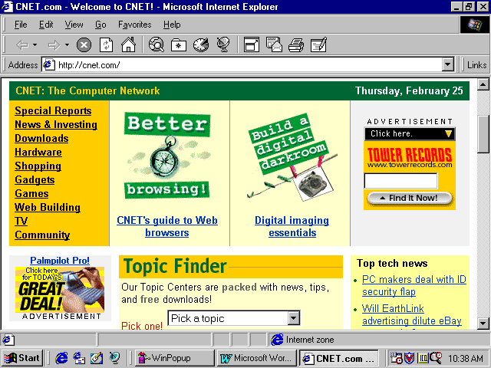
Figure 1
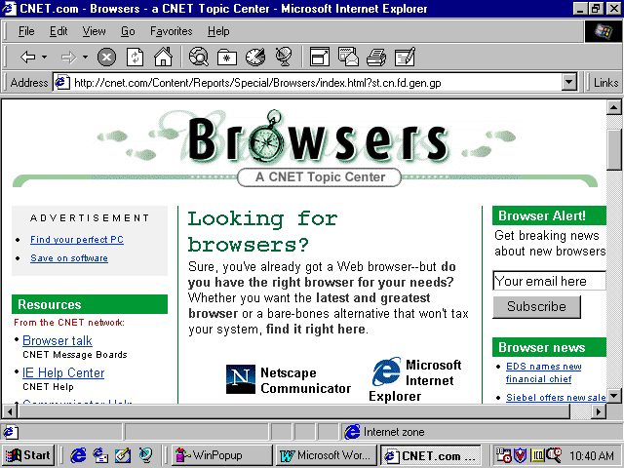
Figure 2

7. Browsers
A browser is the software that is used to view Web pages.

Browsers are of two types:

- Text based browsers
These browsers only show textual information. They are not equipped to show graphics, movies and sounds. However, they make it easy to pick and follow links by selecting the appropriate highlighted text. For example: Lynx.

- Graphical browsers
All graphical Web browsers allow the user to just point and click to access information. They have the capability to support hypermedia i.e. sounds, movies, formatted text and graphics. The most popular graphical browsers are:

- Netscape Navigator
- Internet Explorer
- Mosaic

Browsers allow the user to specify the location of the web page to be viewed. Clicking on links opens the specified page in the browser.

8. Web Servers and Addresses
Web pages must be accessible to all on the Internet and are stored on special computers called as Web servers. Each web server is assigned a unique address of the format:

www.nameofsite.typeofsite.countrycode

Typically, web addresses start with ‘www’. The ‘nameofsite’ is the name of the organisation or person whose page we are trying to access. ‘Type of site’ is a three character code indicating the nature of work. For example, ‘com’ stands commercial organisations, ‘edu’ stands for educational and ‘org’ for non-commercial organisations.

‘countrycode’ is a two character code indicating the country in which the web server is located. For example, ‘il’ is for Ireland, ‘de’ for Germany and ‘gu’ for Guam.

The site address is also referred to as the URL or the Uniform Resource Locator.

- Web servers based in US do not need the country code.

Figure 3 shows the home page of the company Microsoft as viewed in the browser Microsoft Internet Explorer.

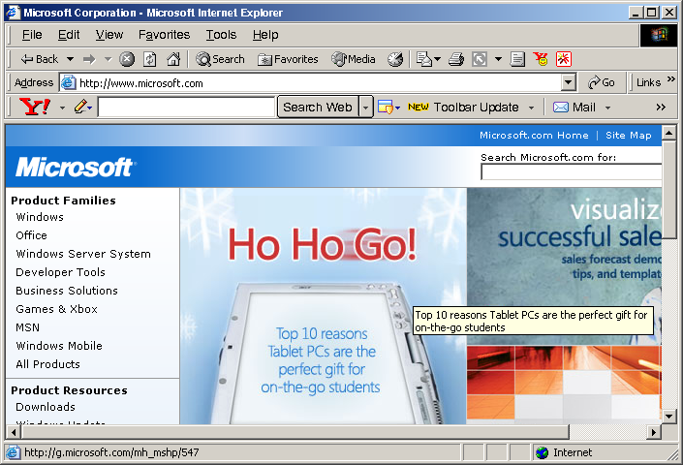
Figure 3
- The bar below the menu bar is called the navigation tool bar. It contains buttons for navigation on the World Wide Web.

- The URL of the home page appears in the list box with the caption Address. It is below the navigation bar.

- The text that is underlined is hyperlinked to other documents that contain related information. Clicking on any of these will open the associated page.

9. Search Engines
Even though the World Wide Web simplifies accessing information, its vastness makes it a little difficult to find the relevant information quickly. To make searching easier, search engines were developed.

Search engines are software on the Web that help the user to look for specific information. They search for information on the Web on the basis of certain keywords specified by the user. The result of the search is a list of documents that contain the keywords.

However, the list could be a long one and could include more than fifty documents. To narrow down the search, there are several options that can be applied.

Consider the case where information on public health services is required.

- Type in “public health services” with the quotes. This will ensure that documents that contain the phrase “public health services” are given priority.

- A search using +“public health services” will ensure that only documents that contain the exact phrase “public health services” will be retrieved. Using the + in front of a word or phrase during search implies that the word or phrase must be present in the document being retrieved.

- If the search string is +“public health” –service then, only documents that contain the phrase “public health” are retrieved The use of the – indicates that documents that contain the word service must be omitted.

Some of the popular search engines on the Web are:

- Yahoo – www.yahoo.com
- Altavista – www.altavista.digital.com
- Infoseek – www.infoseek.com
- Excite –www.excite.com
- WebCrawler – www.webcrawler.com
- Google-www.google.com

Figure 4 displays the screen of Yahoo! one of the most popular search engines.
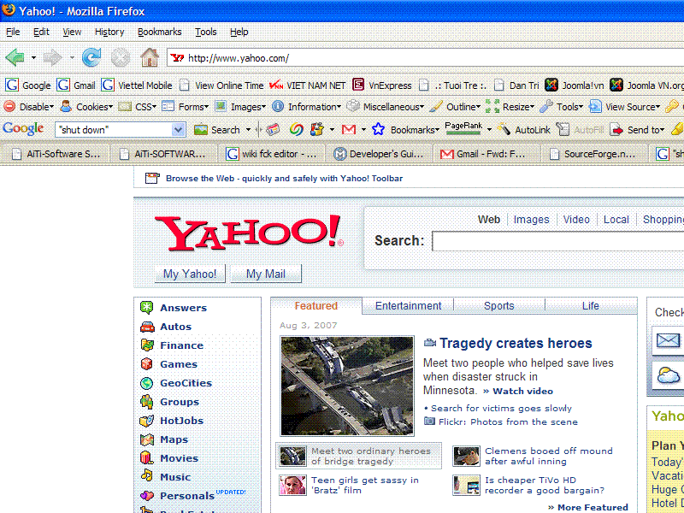
Figure 4

Search engines usually refer to the programs that are used to search for data on the World Wide Web. Programs like WAIS and Gopher are also search engines. They are used to search for data in databases across the Internet.

The advancements in the Web are leading to the merging of the lines of difference between the search engines on the Web and the Internet. For example, Yahoo, a Web search engine gives the user an option to search for data in newsgroups such as Usenet (a network of mail servers created to enable exchange of information between groups with common interests), which is a part of the Internet but not of the Web.

10. Introduction to HTML
Text processing and word processing systems have information to describe how the text of the document is to be displayed. This information is called markup.

In 1980, a mark up language was developed to create documents that could be displayed consistently on computers using different hardware and operating systems. It was called the Standard Generalized Markup Language or SGML.

SGML is a general-purpose tool to describe documents of any kind. SGML documents are not restricted to a single application, formatting style, or processing system.

HTML or Hyper Text Markup Language is defined using the Standard Generalized Markup Language. It is a way of incorporating text, graphics, sounds and videos all in one document called a Web page.

These documents can be displayed using Web browsers. It provides links to other resources using hyperlinks. It also has the capability to work with other Internet protocols and services on the Web like FTP, Gopher, Usenet, e-mail, WAIS, Telnet and HTTP.

HTML is based on two concepts:

- Hypertext:
It provides a way to create a link between information in the same document as well as in different documents.
- Markup language:
Mark up refers to the special tags that are a part of the HTML document. These tags specify how the document content should be displayed.

Benefits of HTML
- HTML is a simple but powerful language to use. The simplicity of HTML allows anyone to create Web pages.

- The Web pages can be linked together using links and Uniform Resource Locators. Thus a user has to just click on hyperlinks to get access to related information.

- Using URLs it is even possible to link to documents through Telnet, FTP, Usenet newsgroups, or even email.

- HTML also allows for the incorporation of multimedia files in the HTML documents. If the browser has the capability to play the sound or movie files then the user can view them just by clicking on them.

Structure of an HTML document
Every HTML document should have the following structure:

- A head:
HTML includes a pair of tags, <HEAD> and </HEAD> to identify the head of a document. Many browsers don’t require this tag, but for readability and structure, it is better to use it.

The head contains the opening <HTML> tag. Every HTML document must have this tag as the first line and the closing tag </HTML> as the last line. These tags identify the document as an HTML document to the browser.

The opening <TITLE> and closing </TITLE> tags also appear in the head of the document. The text between the title tags appears in the title bar of the browser’s window.

- A body:
The body of an HTML document contains the text that will show up on the Web page. It also contains all the links to other information that is related to the page. Majority of HTML tags occurs within a document’s body.

The body section is enclosed within <BODY> and </BODY> tags. It has a description of the document’s layout and structure. A variety of tags for text headings, embedded graphics, text paragraphs, lists, and other elements are used.

Refer to Figure 5 for the structure of an HTML document.
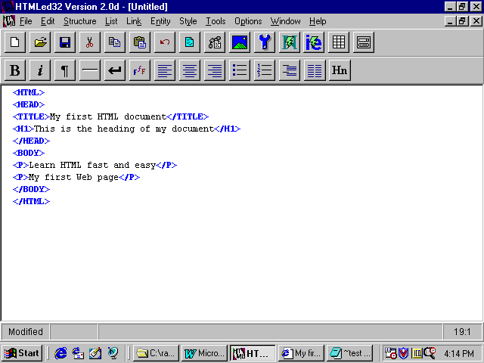
HEAD
BODY
Figure 5

The output of the above code is displayed in Figure 6.
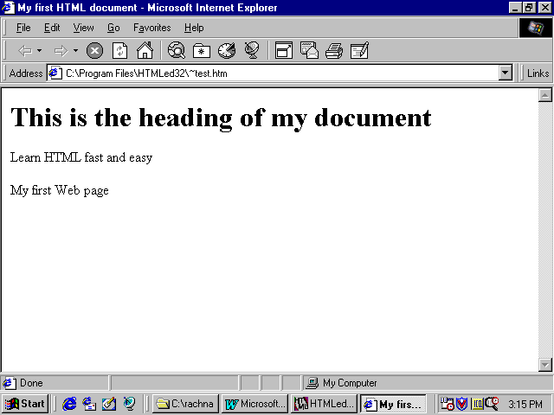
Figure 6

HTML files include both control information (tags) and content (text), which together describe the appearance and contents of Web pages.

An example of a tag:

<B>My Personal Home Page</B>.
<B> and </B> are the opening and closing tags that will display the text ‘My Personal Home Page’ in bold on a Web page.

The following syntax should be kept in mind while writing HTML documents:

- Each tag is enclosed in a <(left bracket) and > (right bracket). These special characters are what differentiate the tags from ordinary text.

- There is an opening and closing tag name for each tag.

- Opening is denoted by <>, for example, <I>:
This is the opening tag to display text in Italics.

- Closing tag is denoted by </>, for example, </I>:
This is the closing Italics tag.

- Closing tags may not be required for some of the tags. But it is better to write closing tags for all.

- Tag names are not case sensitive but generally they are written in uppercase so as to distinguish them from the normal text.

- Tags can have attributes which have values, for example: “align=center” where align is an attribute and its value is centre. This attribute can be used to align text in the centre of a page.

- The “&” can be used to display special characters.

Sometimes it is necessary to insert one set of markup tags within another to get the required display result.

Enclosing one markup in another is called nesting.

11. TCP/IP – An Overview
TCP/IP stands for Transmission Control Protocol and Internet Protocol. Computers connected to the Internet use these protocols to communicate with each other. Basically, they define how computer networks on the Internet exchange messages or data.

The TCP/IP suite of protocols was developed by Vinton Cerf and Robert Kahn in 1974.

Transmitting Messages
Every node (computer) on the Internet has an address made up of four numbers. Each number should be less than 256. For example, 202.54.1.1. Each machine has a unique address on the entire Internet.

To send a message from one computer to another, we need to specify the address of the destination computer. Also, if the message is long it is broken up into multiple packets and each packet is sent individually and the whole message is reassembled at the receiving end.

Also on the Internet are routers whose job is to send data along different paths so that it may reach its destination.

At the receiving end, the different packets are put together to form the complete message.

The process of sending across a message using TCP/IP is described below:

- The Transmission Control Protocol takes care of dividing the messages into packets. A packet is an electronic envelope which contains:
  - The address of the source and the destination machine.
  - Information about the size of the packet.
  - Information about where it fits in the series of packets that make up a large message.

- The Internet Protocol addresses these packets and then mails them.

- The packet will be received by the computers called routers. Routers will then pass it on to other routers.
  - The path travelled by the packet may not be the shortest possible one.
  - All packets need not follow the same path.

- At each point, an attempt is made to locate the destination computer.

- Finally, the packets will reach their destination computer and not necessarily in the sequential order.

- While receiving, the IP receives the packets and gives them to TCP.

- TCP confirms that all the packets have been received.

- Finally it puts the packets together again.

12. Applets
Consider two advertisements seen in a movie theatre:

- One with dynamic images and movie/sound clips.
- The other plain, static slides

Predictably, the former advertisement would be much more appreciated because of its greater visual appeal.

The World Wide Web too, is a global marketing medium. Dynamic images, flashing/scrolling text and animation would leave a greater visual impact on its audience than static text and images.

A Web page designed using HTML is a static page. Thus, the information presented on it is constant. One way to prepare dynamic HTML pages is using Java Applets.

What is a Java Applet?
A Java Applet is:

- A program written in the Java programming language.
- It can be embedded in an HTML page.
- It has to be executed from within a Web browser.

Java applets do not become a part of the HTML files. They are stored separately in another file. A link is maintained between the two files.

At the time of loading of the Web page, the applet is loaded onto the local machine and run by the browser. The applet then performs the task it is required to do.

However, there are a few restrictions on the applets:

- Applets cannot read or write files on the local machine.
- They cannot communicate with any server except the one on which they reside.
- They are not allowed to execute any applications on the local machine.

These restrictions make sure that the applets cannot cause any damage to the files on the local machine.

13. Internet Usage
When it first started, the ARPANET (from where the Internet began) connected only four sites, and only a few hundred people had access to it. Each of the four sites had it’s own local network. Presently, the Internet has grown to more than 10,000 networks from the original four.

The Internet has some base networks supporting it. Earlier, the ARPANET was the one of its main networks. Today, several networks form its base. One of the most important is the NSFNET. These main networks provide reliable and high speed data transfer.

By 1972, there were 40 different sites attached to the ARPANET. The ARPANET was started for the purpose of sharing data. The traffic between its sites included small text files sent between individual users.

The Internet’s phenomenal growth has made it a global marketing medium and a commercial business area. Communications companies, telephone companies, and cable television firms, and corporates, all want to be a part of the Internet phenomenon.

Currently the Internet is being used:

- For emailing
- For exchange of data and information
- As a forum for discussions, exchanging information and news between special interest groups
- For on-line conversation
- For commercial or business transactions
- For on-line training
- For recruitment purposes
- For entertainment
- For accessing information on any topic in the world

Some of the areas where the Internet is being used have been discussed below.

E-commerce
E-commerce stands for electronic commerce. With the Internet, the customers can view the available products and/or services on-line, select the product(s) that he wants to buy and place an order for these products. Payment details are also specified on-line. Payment is typically done by specifying a Credit Card number. The customer is charged on his credit card for the purchases made and will pay for them when he receives the credit card bill.

Businesses are joining the Internet faster than any other group of Internet users. It meets many of their needs, including:

- Advertising and marketing
- Research and development
- Customer support
- Supplying information
- Taking orders
- On-line surveys
- Recruitment
- Selling

The commercial users of the Internet are from various industries like computer-related industries, oil companies, pharmaceutical companies, healthcare-related industries, financial services, banks and many more.

Even small companies and individual entrepreneurs use the Internet to maintain contact with the global market.

Many types of businesses have started appearing on the net. Some of them are:

- Book sellers
- Travel agencies
- Courier companies
- On-line shopping
- E-zines (electronic magazines)

The speed and the size of the Internet are an advantage for commercial ventures. It provides a place where they can reach their customers, promote their products, and provide information to others. It provides a great many advantages:

- Global communication:
The Internet provides rapid communication facilities at the cost of a local phone call. It allows the users access to a world market. Even small, rural businesses have easy access to the global market.

- No time zone difference problems:
The use of facilities like email and on-line chatting enables the companies to be in contact with the suppliers, clients, and employees inspite of time differences across continents. E-mail messages can be accessed at the user’s convenience. For immediate contact, on-line chatting is a good tool.

The Internet has made it possible for employees to live and work at a distance. They need not go into the office physically. Transfer of information, and meetings can take place over the net.

- Customer feedback and support:
One of the main advantages of the Internet is being able to maintain good contact with the customers. Customers can contact companies at any time of the day or night using e-mail and obtain information by way of Gopher and FTP. The use of the Internet helps in maintaining a close relationship with the customer.

- Marketing and Sales:
A web site on the World Wide Web can provide the company with a global presence. Companies can establish this presence by using tools like Usenet, Gopher, FTP Telnet, and e-mail. Businesses can carry out marketing research online.

- Information Resources:
Organisations need all kinds of latest information. Many businesses rely on the latest scientific and /or governmental information for their operations. The Internet provides this information in abundance.

- Supplier support:
Contacting old and new suppliers can be done speedily over the Internet. This in turn can speed up the procedure to obtain supplies.

On-line Supermarkets
On-line supermarkets refer to the sites on the Internet that sell items like books, music tapes, and deliver flowers across countries. Some sites even have the facility to book movie tickets and have them delivered. For example, Amazon.com, BarnesandNoble.com.

The advantages of these sites are:

- The user can browse through the products available with that supermarket, from home at his convenience.
- Products that may not be available locally can be bought through these sites.

However, the disadvantage lies in the time taken for the delivery of the product. Delivery may not be as quick as desired.

On-line supermarkets are getting popular and soon people would be able to buy garments, household products, and probably even computers on the Internet.

Figure 7 shows the Web site of a supermarket called Raley’s & Bel Air. It has on-line services like helping the customer to make a shopping list (Figure 8) and filling out medical prescriptions (Figure 9).

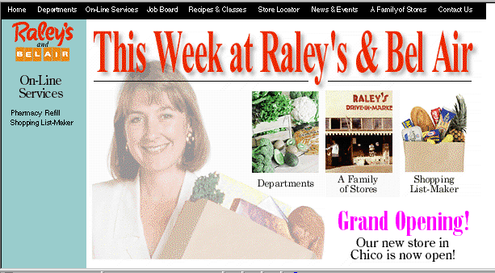
Figure 7

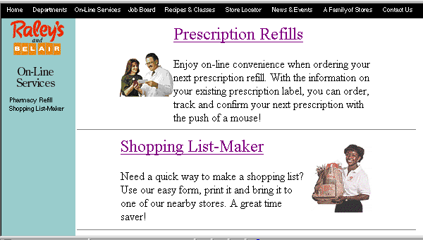
Figure 8
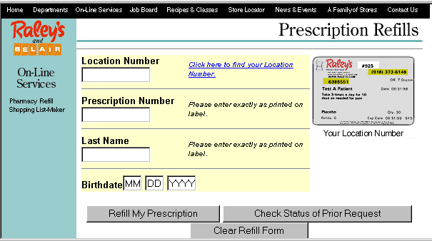
Figure 9

Universities /on-line courses
Many universities have Internet connection. The universities on the Internet tend to exchange resources to help each other. They also use the Internet to put up publications, announcement of conferences and vacancies.

The universities also put up information about student loans grants, scholarships and work-study programs on the Internet.

Many universities provide Internet access to their students.

Potential students, local as well as from other countries, seeking admission to universities abroad, can access their web sites. The web sites provide information on the courses and programs offered.

The students can correspond with the universities regarding the admission procedures via e-mail. E-mail proves to be a much cheaper and faster option than the conventional modes of communication.

Most universities place a lot of importance on research, especially research that brings in grant money. Many government agencies place their grant offers on relevant Internet mailing lists and Usenet groups.

The Internet proves to be a useful tool to researchers:

- Many academic researchers need supercomputers to run programs that perform complex computations. The programs cannot be executed on the university computers. The Internet has sites where researchers can access supercomputers and pay for their use.

- Researchers can download software including editors, compilers, spreadsheets, databases, and analysis tools to help them in their research.

- They can conduct surveys by posting questionnaires on an Internet mailing list or Usenet newsgroup.

- Hundreds of academic libraries can be accessed for information on the Internet.

- Articles written by researchers have to be reviewed by peers. This is to verify their accuracy before they can be published in journals. By putting up the articles on the Internet, the peer-review process can be speeded up.

- Academic researchers can exchange and discuss ideas via e-mail and by conducting public discussions in mailing lists and Usenet newsgroups.

- Databases containing the research information are being put up on the Internet. Other researchers and the general public can access these databases for information.

- Publishing articles on the net offer advantages like faster publishing, easier distribution, and reduced cost. Articles can take months to get published through the normal publishing process. However, on the Internet, the whole process could take just a few weeks.

Another area in academics where the Internet is gaining popularity is distant learning. It has been implemented by using e-mail, Gopher and FTP. People can take these courses while sitting at home or in the office.

Taking courses via the Internet has several advantages:

- There is more and faster interactivity between the student and the faculty than in a traditional, paper-based correspondence.

- The student can access the Internet from any place in the world. Thus, the study material can be accessed from anywhere without any break in continuity.

- Many courses use Gopher and FTP to make information available. This allows the students to explore the study material at their own pace.

- In traditional distance education, access to books, materials and libraries was difficult. However, over the Internet the students are able to access databases, articles, journals and libraries.

Distance education is moving toward a virtual reality environment, where the user will go through the experience of being present in an actual classroom. The students and the faculty will be able to assemble in a class-like environment on the Internet. Special hardware and software will be required to implement a virtual classroom.

Session In Brief
- Storage medium like hard disk are logically divided and sub divided into primary and extended partitions.

- The concept of partitioning has come about for facilitating storage of more than one OS on a system simultaneously.

- The partition from which, we wish the OS to get loaded by default when the system is turned on is known as the active partition.

- File system is used to manage file storage and retrieval.

- Volume refers to a disk area, may span over more than one disk.

- The Internet or the net is a network of networks, all freely exchanging information. It is also referred to as the Information Superhighway.

- The Internet originally started off as a network called the ARPANET, a project started by the Department of Defence (DOD), U.S.A, in 1969

- The Internet has many components. Some of these are:
  - Email
  - FTP
  - WWW
  - Telnet
  - ….

- World Wide Web (WWW) or the Web is a system that allows users to have access to almost any document that is on the Internet. It could be sound recording, or video image. It has made looking for information fast, powerful and easy.

- A browser is the software used to access the Web. The most popular browsers are Netscape Navigator, Internet Explorer, Mosaic and Lynx.

- Search engines are software on the Web that help the user to look for specific information. All that is required is to type in key words, and the search engine will show a list of the documents that contain the words.

- HyperText Markup Language or HTML is a way of representing text and linking that text to other kind of resources like sound files, graphics files, multimedia files.

- TCP/IP stands for Transmission Control Protocol and Internet Protocol. Computers connected to the Internet use these protocols to communicate with each other.

- A Java Applet is a program written in the Java programming language. It allows HTML authors to include live audio, animation, or applications in their Web pages.

- Currently, the Internet is being used for emailing, on-line training and chatting, accessing information, and for commercial transactions.

E-commerce stands for electronic commerce. The Internet meets many needs of businesses like marketing, customer support, selling and research.

On-line supermarkets refer to the sites on the Internet that sell items like books, music, and deliver flowers across countries.

Many universities have Internet connection. The universities on the Internet tend to exchange resources to help each other. They also use the Internet to put up publications, announcement of conferences, and vacancies.

Check Your Progress
- ______________ became so popular that all the universities in the country wanted to join it.

- FTP stands for ______________________________.

- Software used for viewing web pages is called .

- The site address is also referred to as the .

- HTML stands for .

- TCP/IP stands for ___________________________________.

- Every node on the Internet has an address. True/False.

- The Internet Protocol takes care of dividing the messages into packets. True/False.

- Applets can read from and write to files on the local machine.
True/False.

❖    

